**Massachusetts Society for Respiratory Care, Inc.**

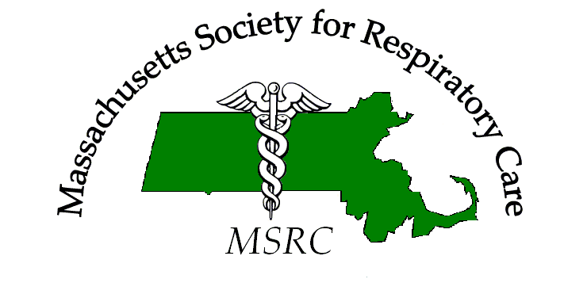

Scholarship Application

Student Questionnaire Worksheet

**Baccalaureate/Masters/Doctorate Award**

**Please use this form as a guide to complete the online application. Only online submissions will be accepted. If you have difficulties or issues with the online system, please contact us at** [**www.msrcol.org/contact-us**](http://www.msrcol.org/contact-us)**.**

|  |  |  |  |
| --- | --- | --- | --- |
| Name: | | | |
| Address: | | | |
| City: | State: | | Zip Code: |
| Home Phone: | | Cell Phone: | |
| Email: | | | |
| School Attending: | | | |
| Matriculated Degree: | | | |
| AARC Number: | | Date Joined: | |

NOTE: The MSRC will not sell or distribute your personal information

**Instructions:** All questions need to be answered for this application to be considered. Complete answers are appreciated.

Application Check List: Please make sure that all items have been completed and are included in the packet. Please attached completed packet at [www.msrcol.org/student-scholarship](http://www.msrcol.org/student-scholarship)

 Student Information Form

 Documentation of acceptance and enrollment in a program. (Save as PDF files and upload)

 Student Essay Questions (see next page)

**Below are several short essay-style questions.**

|  |
| --- |
| 1. **How long have you been a respiratory therapist? In what capacity (staff, supervisor, manager, other)?** |
|  |
| 1. **What does membership to the AARC/MSRC mean to you? How long have you been a member?** |
|  |
| 1. **Please write about how you specifically have promoted the profession of respiratory care.** |
|  |
| 1. **How will earning this degree have an impact on your practice? How will this have an impact on you?** |
|  |
| 1. **Is there is any more information that you feel the Committee should know about your practice?** |
|  |

**PARTICIPATION:**

The MRSC would like applicants to attend a Board of Directors meeting. They are held the second Thursday each month from 5:00 pm to 8:00 pm. The first hour is for the Program and Education committee with the remaining time dedicated to the Board’s duties. Please send us a message at [www.msrcol.org/contact-us](http://www.msrcol.org/contact-us) to notify the Board of your intention to attend a meeting. Meeting attendance **must occur before** August 09, 2018 to qualify. Please note that attendance is not mandatory, but strongly suggested.